Procedimento nota fiscal de transferência:

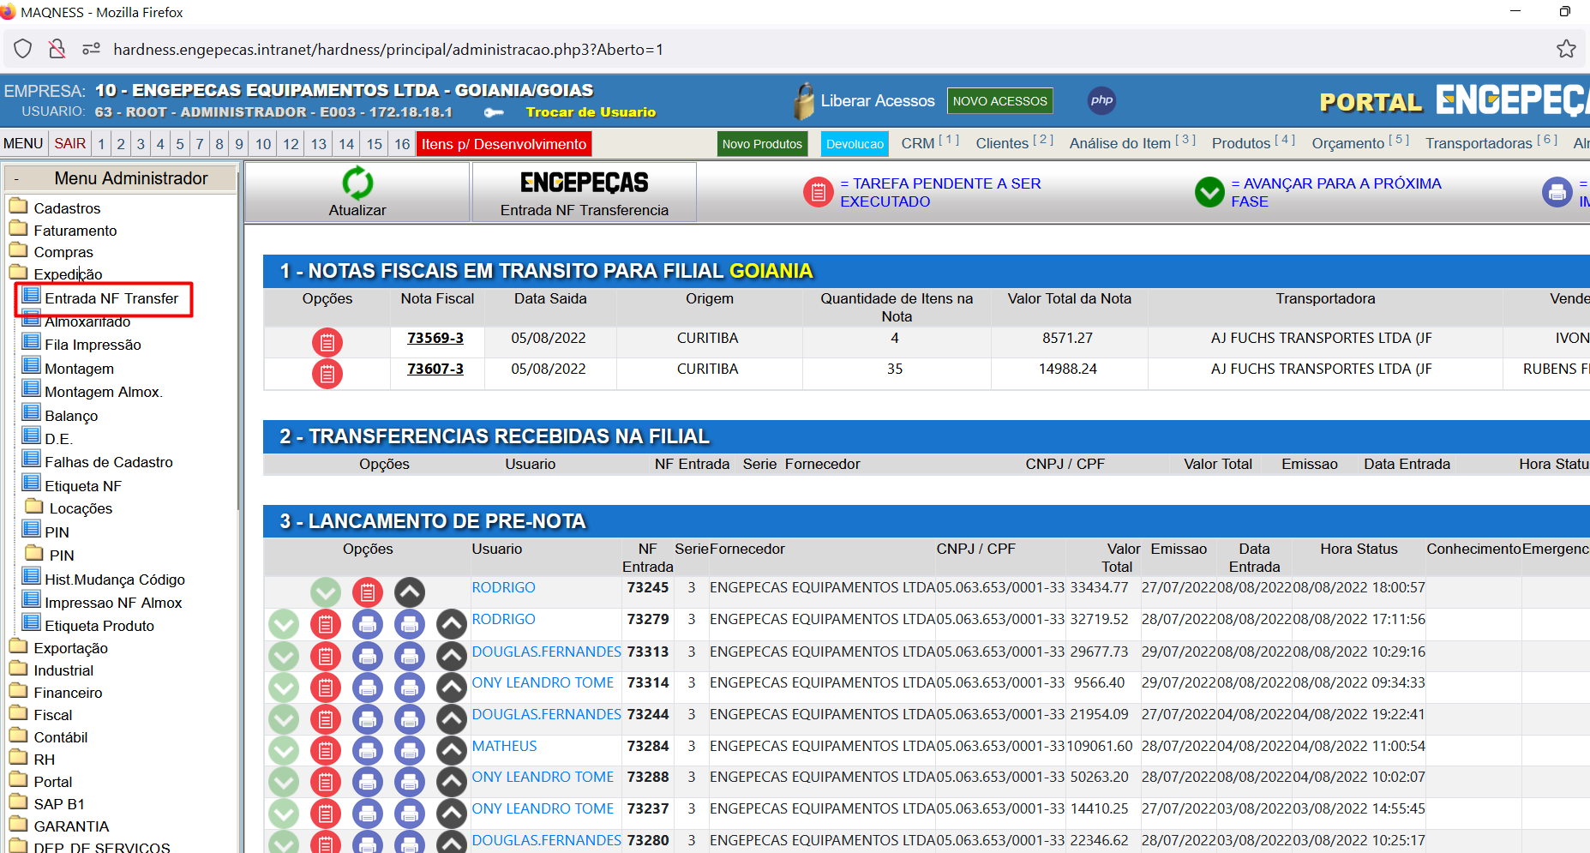

Fontes: Z:\hardness\almoxarifado_recebimento\almoxarifado_fme_transferencias.php

Z:\hardness\almoxarifado_recebimento\inc_almoxarifado_principal_status_TRANSFERENCIAS2.php

**select** * **from** T214

**where** 1=1

**and** T214_T007_Id =

**AND** T214_Numero_Nota_Fiscal =- 73245

-- tela de carga de notas em transferencia

(**select** T007_Numero_Nota_Fiscal **AS** Numero_Nota_Fiscal, T007_Numero_Serie_Nota_Fiscal **AS** Numero_Serie_Nota_Fiscal, T007_Data_Emissao **AS** Data_Emissao, T007_Valor_Total **AS** Valor_Total, T008_TOTAL_ITENS(T007_Id) **as** Total_Itens, '1' **as** T214_Flag_Status, T240_T007_Origem **as** T007_Id, T007_Nome_Transportadora **AS** Nome_Transportadora, T007_D022_Id, T240_C004_Origem, CO.C004_Cidade **as** C004_Origem, **case** **when** T240_C004_Origem = '5' **then** (T007_Data_Emissao - **date_sub**(**current_date**(),**interval** 20 **day**) ) **else** (T007_Data_Emissao - **date_sub**(**current_date**(),**interval** 10 **day**) ) **end** **as** Prazo_Faltante_Entrega, T214_C007_Id_Almox_Status_Recebida, T214_Data_Almox_Recebida, '0' **as** T013_Id, **IFNULL**(T007_C007_Id_Vendedor_Interno,0) **as** T013_C007_Id, '0' **as** T013_C004_Id, '0' **as** T013_D024_Id, '0' **as** T013_C008_Id, '0000-00-00' **as** T013_Data_Entrada, '0' **as** T013_Numero_Conhecimento, '0' **as** T013_Numero_Controle, '0' **as** Total_Conferidos, '' **as** Usuario_Almox_Status_Recebida, '' **as** Usuario_Almox_Status_PreNota, '' **as** Usuario_Almox_Status_PreNota_SemConhecimento, '' **as** Usuario_Almox_Status_Conferida, '' **as** Usuario_Almox_Status_Armazenada, '' **as** Usuario_Almox_Status_Finalizada, '' **as** T214_Observacao_Almox_Recebida, '' **as** T214_Observacao_Almox_PreNota, '' **as** T214_Observacao_Almox_Conferida, '' **as** T214_Observacao_Almox_Finalizada, '0000-00-00' **as** T214_Insercao_DataHora, '' **as** T214_C007_Id_Almox_Status_PreNota_SemConhecimento, '0' **as** T014_Id

**FROM** T240 **INNER** **JOIN** C004 **as** CO **ON** CO.C004_Id = T240_C004_Origem

**LEFT** **JOIN** T007 **on** T007_Id=T240_T007_Origem

**LEFT** **JOIN** T214 **on** T007_Id=T214_T007_Id

**WHERE** T240_Id_Historico_TF_Inicio **is** **not** **null** **AND** T007_Flag_Cancelada <> 'S'

**AND** ((T214_Flag_Status =1) **or** (T214_Flag_Status **IS** **NULL**))

**AND** T240_C004_Destino= 10 **AND** T240_Flag_Historico_TF_Concluido **is** **null** )

**select** T214_Flag_Avanco_Retorno,T007_Numero_Nota_Fiscal **AS** Numero_Nota_Fiscal, T007_Numero_Serie_Nota_Fiscal **AS** Numero_Serie_Nota_Fiscal, T007_Data_Emissao **AS** Data_Emissao, T007_Valor_Total **AS** Valor_Total, T008_TOTAL_ITENS(T007_Id) **as** Total_Itens, '1' **as** T214_Flag_Status, T240_T007_Origem **as** T007_Id, T007_Nome_Transportadora **AS** Nome_Transportadora, T007_D022_Id, T240_C004_Origem, CO.C004_Cidade **as** C004_Origem, **case** **when** T240_C004_Origem = '5' **then** (T007_Data_Emissao - **date_sub**(**current_date**(),**interval** 20 **day**) ) **else** (T007_Data_Emissao - **date_sub**(**current_date**(),**interval** 10 **day**) ) **end** **as** Prazo_Faltante_Entrega, T214_C007_Id_Almox_Status_Recebida, T214_Data_Almox_Recebida, '0' **as** T013_Id, **IFNULL**(T007_C007_Id_Vendedor_Interno,0) **as** T013_C007_Id, '0' **as** T013_C004_Id, '0' **as** T013_D024_Id, '0' **as** T013_C008_Id, '0000-00-00' **as** T013_Data_Entrada, '0' **as** T013_Numero_Conhecimento, '0' **as** T013_Numero_Controle, '0' **as** Total_Conferidos, '' **as** Usuario_Almox_Status_Recebida, '' **as** Usuario_Almox_Status_PreNota, '' **as** Usuario_Almox_Status_PreNota_SemConhecimento, '' **as** Usuario_Almox_Status_Conferida, '' **as** Usuario_Almox_Status_Armazenada, '' **as** Usuario_Almox_Status_Finalizada, '' **as** T214_Observacao_Almox_Recebida, '' **as** T214_Observacao_Almox_PreNota, '' **as** T214_Observacao_Almox_Conferida, '' **as** T214_Observacao_Almox_Finalizada, '0000-00-00' **as** T214_Insercao_DataHora, '' **as** T214_C007_Id_Almox_Status_PreNota_SemConhecimento, '0' **as** T014_Id

**FROM** T240 **INNER** **JOIN** C004 **as** CO **ON** CO.C004_Id = T240_C004_Origem

**LEFT** **JOIN** T007 **on** T007_Id=T240_T007_Origem

**LEFT** **JOIN** T214 **on** T007_Id=T214_T007_Id

**WHERE** 1=1

**and** T240_T007_Origem = 9333942

**and** T240_Id_Historico_TF_Inicio **is** **not** **null** **AND** T007_Flag_Cancelada <> 'S'

**AND** ((T214_Flag_Status =1) **or** (T214_Flag_Status **IS** **NULL**))

**AND** T240_C004_Destino= 10 **AND** T240_Flag_Historico_TF_Concluido **is** **null**

**select** * **from** T214 **where** T214_T007_Id = 9333942 **and** T214_Flag_Status = 1

**delete** **from** T214 **where** T214_T007_Id = 9333942 **and** T214_Flag_Status = 1

**select** T007_Numero_Nota_Fiscal **AS** Numero_Nota_Fiscal, T007_Numero_Serie_Nota_Fiscal **AS** Numero_Serie_Nota_Fiscal, T007_Data_Emissao **AS** Data_Emissao, T007_Valor_Total **AS** Valor_Total, T008_TOTAL_ITENS(T007_Id) **as** Total_Itens, '1' **as** T214_Flag_Status, T240_T007_Origem **as** T007_Id, T007_Nome_Transportadora **AS** Nome_Transportadora, T007_D022_Id, T240_C004_Origem, CO.C004_Cidade **as** C004_Origem, **case** **when** T240_C004_Origem = '5' **then** (T007_Data_Emissao - **date_sub**(**current_date**(),**interval** 20 **day**) ) **else** (T007_Data_Emissao - **date_sub**(**current_date**(),**interval** 10 **day**) ) **end** **as** Prazo_Faltante_Entrega, T214_C007_Id_Almox_Status_Recebida, T214_Data_Almox_Recebida, '0' **as** T013_Id, **IFNULL**(T007_C007_Id_Vendedor_Interno,0) **as** T013_C007_Id, '0' **as** T013_C004_Id, '0' **as** T013_D024_Id, '0' **as** T013_C008_Id, '0000-00-00' **as** T013_Data_Entrada, '0' **as** T013_Numero_Conhecimento, '0' **as** T013_Numero_Controle, '0' **as** Total_Conferidos, '' **as** Usuario_Almox_Status_Recebida, '' **as** Usuario_Almox_Status_PreNota, '' **as** Usuario_Almox_Status_PreNota_SemConhecimento, '' **as** Usuario_Almox_Status_Conferida, '' **as** Usuario_Almox_Status_Armazenada, '' **as** Usuario_Almox_Status_Finalizada, '' **as** T214_Observacao_Almox_Recebida, '' **as** T214_Observacao_Almox_PreNota, '' **as** T214_Observacao_Almox_Conferida, '' **as** T214_Observacao_Almox_Finalizada, '0000-00-00' **as** T214_Insercao_DataHora, '' **as** T214_C007_Id_Almox_Status_PreNota_SemConhecimento, '0' **as** T014_Id

**FROM** T240 **INNER** **JOIN** C004 **as** CO **ON** CO.C004_Id = T240_C004_Origem

**LEFT** **JOIN** T007 **on** T007_Id=T240_T007_Origem

**LEFT** **JOIN** T214 **on** T007_Id=T214_T007_Id

**WHERE** 1=1

-- and T240_T007_Origem = 9333942

**and** T240_Id_Historico_TF_Inicio **is** **not** **null**

**AND** T007_Flag_Cancelada <> 'S'

**AND** ((T214_Flag_Status =1) **or** (T214_Flag_Status **IS** **NULL**))

**AND** T240_C004_Destino= 10 **AND** T240_Flag_Historico_TF_Concluido **is** **null**

**select** T240_Id_Historico_TF_Inicio, T240_Flag_Historico_TF_Concluido

**select** *

**from** T240

**where** T240_T007_Origem = 9333942

**update** T240 **set** T240_Flag_Historico_TF_Concluido = **null** **where** T240_T007_Origem = 9328832

**and**

10285562

**UNION**

( **SELECT** T013_Numero_Nota_Fiscal **AS** Numero_Nota_Fiscal, T013_Numero_Serie_Nota_Fiscal **AS** Numero_Serie_Nota_Fiscal, T013_Data_Emissao **AS** Data_Emissao, T013_Valor_Total **AS** Valor_Total, T014_TOTAL_ITENS(T013_Id) **as** Total_Itens, T214_Flag_Status, '0' **as** T007_Id, '' **as** Nome_Transportadora, '0' **as** T007_D022_Id, '0' **as** T240_C004_Origem, '' **as** C004_Origem, '0' **as** Prazo_Faltante_Entrega, '0' **as** T214_C007_Id_Almox_Status_Recebida, '0000-00-00' **as** T214_Data_Almox_Recebida, T013_Id, T013_C007_Id, T013_C004_Id, T013_D024_Id, T013_C008_Id, T013_Data_Entrada, T013_Numero_Conhecimento, T013_Numero_Controle, T014_TOTAL_CONFERIDOS(T013_Id) **as** Total_Conferidos, FN_USUARIO(T214_C007_Id_Almox_Status_Recebida) **as** Usuario_Almox_Status_Recebida, FN_USUARIO(T214_C007_Id_Almox_Status_PreNota) **as** Usuario_Almox_Status_PreNota, FN_USUARIO(T214_C007_Id_Almox_Status_PreNota_SemConhecimento) **as** Usuario_Almox_Status_PreNota_SemConhecimento, FN_USUARIO(T214_C007_Id_Almox_Status_Conferida) **as** Usuario_Almox_Status_Conferida, FN_USUARIO(T214_C007_Id_Almox_Status_Armazenada) **as** Usuario_Almox_Status_Armazenada, FN_USUARIO(T214_C007_Id_Almox_Status_Finalizada) **as** Usuario_Almox_Status_Finalizada, T214_Observacao_Almox_Recebida, T214_Observacao_Almox_PreNota, T214_Observacao_Almox_Conferida, T214_Observacao_Almox_Finalizada, T214_Insercao_DataHora, T214_C007_Id_Almox_Status_PreNota_SemConhecimento, **IFNULL**(T014_Id,0) **as** T014_Id

**FROM** T013

**INNER** **JOIN** T214 **ON** T013_Id = T214_T013_Id

**LEFT** **JOIN** T014 **ON** T013_Id = T014_T013_Id

**WHERE** T214_Flag_Almoxarifado='S' **AND** T214_Flag_Status = '1'

**AND** T214_C004_Id_Destino= 10 **AND** T013_Flag_Trava_Entrada_TF **IS** **NULL** **GROUP** **BY** T013_Id ) **order** **by** T214_Insercao_DataHora **DESC** , Data_Emissao **DESC**